Invention Disclosure Form

- Describe the invention.
1a. Describe the invention in your own words. Is the invention a new process, composition of matter, device or product, system, software, or a combination of these elements?

The current invention mainly focuses on a modified large-scale synthesis method of positive electrode material for lithium-ion batteries (LIBs), particularly Ni-rich layered metal oxide and its combinations. In a conventional synthesis method, metal precursors are dissolved and co-precipitated using a base solution in a reactor, followed by stirring for a long duration. In making powders, the metal solutions are added to the reactor in a specific mL/min along with the chelating agent, say ammonia, at a constant temperature (40°C - 60°C) and pH (primarily basic). During this process, the precursors are continuously pumped into the reactor until the desired particle morphology, distribution and size are achieved, and the reaction may proceed for 24 to 48 hours based on the required output. The reactor used is called a Continuous Stirred Tank Reactor (CSTR), which by design has an overflow valve where, during the prolonged reaction time, the waste particles get ejected through the valve. This leads to the generation of more waste than the product. Moreover, the starting materials for the reaction are higher in quantity than the product output. This results in high pricing of Ni-rich cathode materials, thus making the battery price higher. The proposed invention, however, involves limited usage of the precursors for the synthesis without compromising the quality and performance, thus limiting the wastage produced during the reaction. This cost-effective approach makes our invention a viable solution for commercial applications, reassuring potential investors and technical experts about its economic benefits.

Title: Economic and Efficient Synthesis of Ni, Co, Mn (NCM) compositions using Continuous Stirred Tank Reactor

1b. Does the invention provide a new use of, or an improvement to, an existing product or process?
The synthesis of Ni-rich oxides by the co-precipitation process using CSTR is commercially well-known, and several studies have been conducted to perfect the synthesis procedure. As mentioned, the existing technique uses a continuous flow of metal precursors, base solution, and a chelating agent throughout the reaction, say 12, 24, or 48 hrs. Thus, a massive quantity of precursor solutions is overflown as waste, and the cost of the raw materials and reaction time is much higher, making the battery more expensive. Our invention, however, introduces a novel approach that focuses on reducing chemical wastage, optimising the flow rate and reaction time, thereby minimising the resultant output waste. This unique approach sets our invention apart and makes it a compelling solution to the current challenges in lithium-ion battery production.
- Our invention's prime novelty is utilising a stoichiometric quantity of precursors without excess flow into the reactor tank. The flow of the chemicals is restricted to stoichiometric quantities, saving close to 150% of the precursor solution and limiting the reaction time to 12 hours.
- Another modification is the flow rate of the solutions and the chelating agent ammonia. The flow rate significantly impacts the outcome of the reaction and the flow rate, which in this invention proposes to provide better yield and uniform secondary particles.
- The particle size, morphology and specific capacity attained by synthesising through this method is comparable to that of conventional procedures.

- From the description, identify and provide a detailed description of specific novel and unusual features.

The various Ni, Co, Mn (NCM) precursor compositions are synthesised in a continuously stirred tank reactor by the co-precipitation method. For example, the NCM-622 precursor is synthesised by a co-precipitation reaction in CSTR.
In a preferred embodiment of the present invention, the method of synthesising the NCM-622 precursor by using CSTR comprises the following significant steps:
  - The setup comprises a tank, a propeller for mixing, a pH sensor, a temperature sensor, and multiple dosing pedestal pumps for pumping the chemical solutions into the tank
  - The tank is filled with water and ammonia before starting the reaction. these precursors are further pumped into the tank using the dosing pumps.
  - The volume of the precursors pumped is precisely tuned to a specific volume, like 300-600 ml/per hour for the TM solution and 30-60 ml/hour for the ammonia solution. The given range values result from several experiments to get a more uniform NCM-622 spherical particle.
  - The flow rate significantly impacts the residence time, reaction rate, conversion yield, and mixing efficiency. The slower flow rate will take longer for reactants to react and form the particles, which will result in higher conversion and yield. The adjusted flow rate has proven to have lower wastage and higher yield than the conventional synthesis procedure. The higher flow rate will lead to higher wastage because many unreacted particles will flow out of the reactor during the pumping.
  - The metal precursor, NaOH, and Ammonia solution are pumped into the reactor only once and not the conventional continuous supply until the desired particle size is achieved. With the adjusted flow rate, this step is important because it drastically reduces the amount of the starting materials used and thus reduces the overall cost of the end product.
  - The RPM (1200), pH (11), and Temperature (50 °C) are accurately maintained at the values deduced after various experiments.
  - The reaction time is further optimised to 12 hours. The particle size achieved after the reaction time is approximately 3-6 µm.
  - The acquired particles are washed until the ammonia is washed away, filtered, and dried at 80 °C overnight.
  - Then, the hydroxide precursor is mixed with the LiOH and calcined at 450 °C for 5 hours and 780 °C for 18 hours to get the final LiNi_{0.6}Co_{0.2}Mn_{0.2}O₂.
The processing steps listed above not only lead to the efficient synthesis of NCM-622 but also limit the waste generated from the reactor, significantly reducing the cost of the end product.

The Uniqueness of our invention:
- The present invention establishes a unique synthesis procedure for synthesising NCM-622 hydroxide precursor by limiting the supply of starting metal oxide precursors.
- By limiting the supply of the starting metal precursors to a stoichiometric amount, the precursor waste from the reactor is drastically reduced.
- For example, adjusting the flow rate to 300 ml/hr has produced a better hydroxide precursor. The factors like back mixing, mixing, heat transfer, and mass transfer are all increased by adjusting the flow rate to the mentioned value.
- The resultant product’s electrochemical performance is equal to that of the commercially available product.

- How does the invention differ from present technology? What problems does it solve, or what advantages does it possess?
The synthesis of various NCM compositions by co-precipitation method using CSTR is well-known, and numerous studies have been carried out to form uniform spherical particles. For example, the advantage of synthesising NCM-622 in the CSTR is the ability to control the particle morphology, which is a critical factor in achieving better performance; rate capabilities have significant improvement in the electrochemical performance. However, wastage is a huge issue in the CSTR process, the continuous flow of the precursor and the higher flow rate contribute to this waste generation during the process. The higher flow rate will push out the unreacted particles, creating more waste. We have modified the flow rate so that there is ample time for the chemicals to react and form primary particles, eventually forming the spherical secondary particles. There are many patents on the CSTR design and synthesis procedure. The patent (US Pat No: US 9923190B2) shows the synthesis of the concentration gradient layer using a batch reactor. The positive electrode material is prepared using a batch reactor comprising a core layer of Ni, Co, and Mn, having high capacity, and a shell layer with the same material for stability. This concentration gradient layer positive electrode material has shown better electrochemical performance due to the two layers of Ni, Co, and Mn, each contributing to the electrochemistry and the CSTR procedure, making it scale up the process. In a conventional synthesis procedure, the continuous flow of the reactants to increase the particle size of the secondary particles is one of the primary reasons for the higher wastage. In our modified method, where we use the one-time flow of the reactants, we can synthesise the cathode of particle size 3 µm, which shows much better performance than the cathode of larger particle size. Sun et al. 2016 proved this claim by synthesising the same NCM-622 precursor using the CSTR technique and different concentrations of the NH₄OH to see the formation of the primary particles. They synthesised secondary particles of various sizes and concluded that the secondary particles of the smaller size (~3 µm) have shown better electrochemical performances in terms of cyclic stability and rate capability than the NCM-622 of the larger particle size. In the patent (US 2020/0203765), the LiNi_{0.94}Co_{0.06}O₂ is the cathode material prepared using the same CSTR process by which they have experimented with KOH as a base. The patent claims to have synthesised secondary microspheres with high tap density by altering the base. Yang et al. (2021) synthesised NCA (expand NCA) cathode particles via the ammonia complexing coprecipitation method in a CSTR. The fine primary agglomerates transformed into spherical-like secondary microparticles with a wide particle size range of 1 to 10 µm. After a 10-hour reaction, the particle sizes of the precipitate decreased, resulting in more uniform spheres with a more regular shape and a denser structure. This suggests that the nucleation, agglomeration, fragmentation, and collision between particles occurred repeatedly and continuously as the reaction proceeded, resulting in spherification and compaction of particles. This further strengthens our claim that the flow rate, RPM, and tank size are all necessary to synthesise well-agglomerated, uniform NCM-622 microspheres.
The currently accepted CSTR process involves a continuous supply of the precursors throughout the reaction time until they achieve the required particle size. The waste discarded from the current procedure is very high, thus increasing the cost of the positive electrode materials. With the controlled flow of the ammonia solution and TM solution, the formation of primary and secondary particles is uniform in size and shape. Henceforth, the present invention proposes the stoichiometric flow of the transition metal precursor solutions and chelating agent at a particular flow rate, maintaining the pH by NaOH in a contact mode, temperature (~50°C), RPM (~1200) throughout the experiment and 12 hours reaction time yielded NCM-622 of particle size 3-6 µm with a uniform spherical morphology.

- Describe the uses, applications and benefits of the invention. what are the possible uses for the invention, particularly the major application(s)?
- The modified co-precipitation processes in the CSTR tank are specifically designed for scaling at the commercial level. Almost all NCM compositions are produced using the modified method. Here, we have disclosed the production procedure for NCM-622
- The fine-tuned flow rate, synthesis time, pH, temperature, and RPM help produce uniform shape/size hydroxide particles with a high tap density.
- The morphology and particle size can be controlled as per the requirement.
- The electrochemical performance of the NCM-622 synthesised from this invention is on par with the commercial NCM-622 available in the market.

- Characterize the disadvantages and limitations of the invention.
Precise reaction conditions need to be maintained to achieve uniform particle size.
Long reaction duration in the CSTR tank is not recommended as it leads to the non-uniform particle size.
The modified method has all the advantages rather than disadvantages regarding chemicals, gas consumption, duration of the reaction, cost of the precursor end product, etc.

- Enclose sketches, drawings, photographs and other materials that help illustrate the invention.
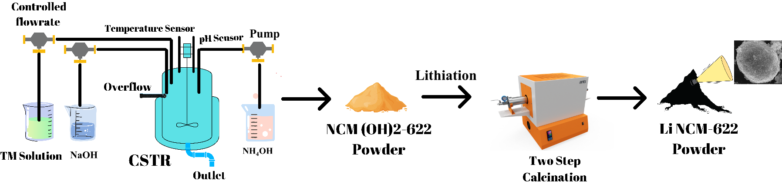

Figure 1: Schematics of NCM precursor synthesis by using CSTR
The present invention discloses the synthesis of NCM-622 using the continuous stirred Tank Reactor (CSTR). The synthesis procedure involves pumping TM solution, NaOH, and NH₄OH into the tank reactor of the size 1 litre. The flow rate is maintained at 300ml/hr for the TM solution, 30ml/hr for the ammonia solution, and NaOH at contact mode. The pH (11) and temperature (50 °C) are maintained throughout the reaction for 12 hours, and all the solutions are pumped into the reactor only once. After the reaction, the hydroxide precursor is filtered and dried and then lithiated by using LiOH at 450 °C for 5 hours and 780 °C for 6 to18 hours to form the lithiated product, in the case of NCM-622 we have heated for 18 hours. In the case of LiCO₃ precursor, the intermediate step at 450°C is not required, and the final temperature is modified to 800 to 900°C/6 to 12 hours duration under an inert atmosphere. However, in the present invention, we use the single-time flow of all the precursors and the modified flow rate so that the formation of the primary particle is appropriate for the further formation of the secondary particles. Figure 1 shows the schematic of the synthesis mentioned above procedure.

- Provide details concerning experimental data. (complete experimental procedure including list of experiments or trials conducted)
Example 1:
The NCM-622 precursor was synthesised as per this invention using the CSTR. The precursor solution was pumped into the reactor as per the flow determined by us; we have conducted multiple experiments with various flow rates, such as 100 ml/hr, 200 ml/hr, 300 ml/hr, and 500 ml/hr, have concluded 300 ml/hr maybe ideal. To observe the particle growth, the sample from the overflow valve of the CSTR was taken and analysed by using a particle size analyser. The sample was taken at intervals of two hours and continued until the end of the reaction. Table 1 below shows the particle growth at each time interval. This experiment is stopped once the desired particle size is achieved. As mentioned in the above literature, the smaller particle is prone to better performance in cyclic stability and rate studies.

Table 1: Particle size data for the synthesised NCM-622.

Time | D₁₀ | D₅₀ | D₉₀
9.00 A.M | 1.89 | 3.76 | 6.40
11.00 A.M | 2.25 | 4.81 | 7.09
1.00 P.M | 2.07 | 4.58 | 8.22
3.00 P.M | 2.49 | 4.63 | 8.26
5.00 P.M | 2.56 | 5.06 | 8.44
7.00 P.M | 2.66 | 5.15 | 8.51
9.00 P.M | 2.72 | 5.37 | 8.87

Example 2:
Next, the synthesised hydroxide precursor is treated with the LiOH to form the lithiated NCM-622 particles. Here the obtained hydroxide precursor of 4 µm size is mixed with the LiOH manually with the help of mortar and pestle. The mixed particle is heat treated in two steps to form the lithiated final product. At first, it is heated at 450 °C for 5 h, and then it is further ground to get a more homogenous mixture and then again calcined at 780 °C for 18 h to get the LiNi_{0.6}Mn_{0.2}Co_{0.2}O₂ cathode material. Table 2 shows the heating conditions used for heat treating the NCM-622 hydroxide precursor.

Precursor | NCM-622(OH)₂
Lithiating agent | LiOH
Heating Temperature | 450 °C for the 1st step and 780 °C for the 2nd step
Holding time | 5 hours for the 1st step and 18 hours for the 2nd step
Heating Rate | 5 °C/min

Table 2: Lithiation conditions for the lithiating the NCM-622 hydroxide precursor.

Example 3:
150 grams of the precursor is obtained using the method shown in Figure 3. The XRD is taken to analyse the phase purity of the obtained sample. The figure shows the obtained XRD data shows the synthesised NCM-622 compound has clear peaks that can be indexed to layered NaFeO₂ structure without extra peaks. The peak splitting of (006)/(012) and (108)/(110) diffraction peaks indicates that all samples have a well-layered structure and the Li⁺/Ni⁺ mixing ratio calculated from the intensity of (003) and (104) planes is of 1.5 % which show the layered structure is without any mixing. Further, the XRD data is refined to get the lattice constant data which is shown in Table 3.

Figure 2: XRD data of NCM-622.

Sample Name | a(Å) | c (Å) | c/a | I₀₀₃/I₁₀₄
NCM-622 | 2.862 | 14.224 | 4.969 | 1.5

Table 3: Lattice parameters data of NCM-622.

Example 4:
The synthesised NCM-622 precursor was further analysed using HR-SEM to find its morphology. The SEM image in Figure 4 (a) shows that the cathode shows homogeneous spherical secondary particles assembled with densely aggregated nanorods. The variation in nanostructure formation can be linked to the quantities of NH₄OH and the stirring speed. Higher concentrations of NH₄OH and increased stirring speed promote the creation of primary grain nanorods, which assemble into secondary particles. Conversely, lower NH₄OH concentrations and slower stirring speeds favour the development of secondary particles comprising primary nanoparticles. The average size is 3 µm determined by the particle size analyser, and the formation of the primary particles can be attributed to the flow rates, NH₄OH concentration, and stirring speed. The faster stirring speed, flow rate, and ammonia concentration are essential in forming the primary particles and then into secondary particles. Figure 4 (b to d) shows the XPS data for the synthesised cathode material. The XPS data shows the presence of Ni²⁺/Ni³⁺, Co³⁺ and Mn⁴⁺ peaks present in the cathode material.
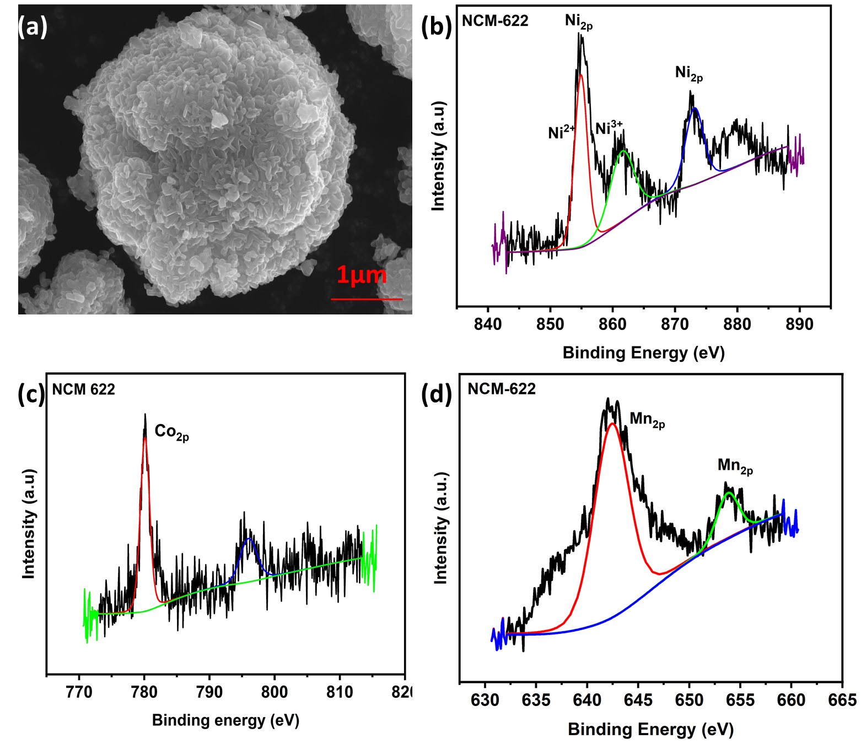
Figure 3: (a)SEM Image of NCM-622, (b to d) XPS Data of NCM-622

Example 5:
To make the electrochemical measurements, 90% of the cathode material is mixed with 5% Carbon black and 5% PVDF binder in the mortar and pestle to get a homogenous mixture. The mixed compound is made into a slurry by adding a few drops of NMP into the mixture and then drop cast into the aluminum foil for the coating. Using the doctor blade technique, the coating is done on the battery-grade aluminium foil. The coated electrode is dried in a vacuum oven at 80 °C overnight to dry the NMP completely. Then, the dried electrode is punched into a 16 mm disk using an electrode cutter and vacuum-dried further before assembling the cells. The CR2032 coin cell was fabricated inside the Argon-filled glovebox, and the electrochemical tests were carried out in the Neware battery tester. The cells were cycled at the voltage window of 2.8 – 4.3 V at 0.1 C rate as the formation cycle and further cycled at 1C rate to analyse the cyclic stability of the cathode material. Figure 5(a) shows the initial charge/discharge cycle at a 0.1 C rate, where the NCM-622 exhibits a discharge capacity of 163.5 mAh g⁻¹ with a Coulombic efficiency of 89.5%. Further, the cyclic studies were conducted at the C-rate of 1 C for 100 cycles, as shown in Figure 5(b), and the cathode retained 78.9% of its initial capacity. The performance can be attributed to the smaller size of the secondary particles mainly because of the more contact between the inner particles of the electrode and the electrolyte. This excellent electrochemical performance and the faster kinetics of ions and electrons transport can be owed to the advantageous structural stability of hierarchical nanorods assembled with 3 µm spherical secondary particles.

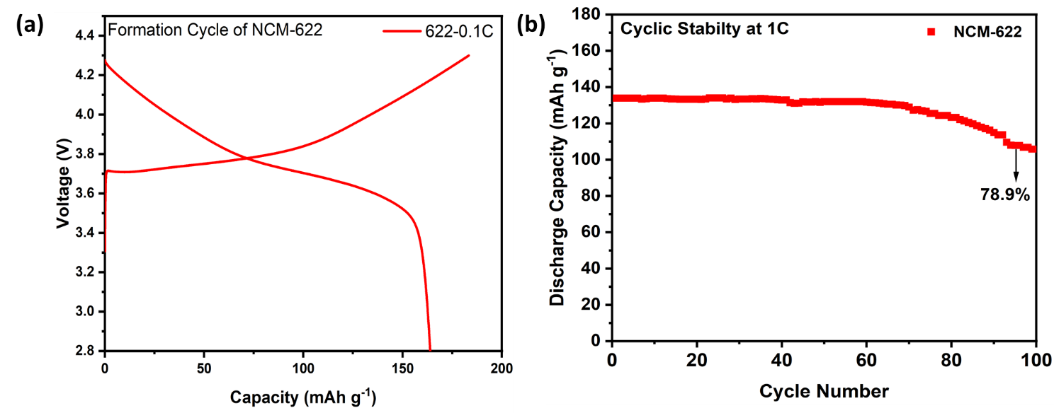

Figure 4: (a) Initial Charge/Discharge of NCM-622 at 0.1C (2.8V-4.2V), (b) Cyclic Stability of NCM-622 at 1C rate.

What is claimed?
- A method for synthesising NCM-622 precursor using the Continuous Stirred Tank Reactor (CSTR). Here, we use a modified synthesis procedure by allowing the flow of precursors to occur only in stoichiometric quantity, not in excess and controlling the flow rate of the metal and ammonia/sodium hydroxide solutions.
- The process according to claim 1: In this modified procedure, the flow of TM solutions and ammonia is controlled at 300 ml/hr and 30 ml/hr, respectively. Moreover, the flow occurs only once during the entire reaction, varying from the conventional procedure of allowing the flow of the TM solution, NaOH, and ammonia continuously for the entire duration of the reaction.
- The process, according to claim 1 and claim 2, the TM solution and NH₄OH solution are pumped into the CSTR through the pedestal pump at the claimed flow rate. The NaOH is kept in contact mode to maintain the control of the pH. The temperature, RPM, and pH are all maintained constant throughout the reaction, which is done under the N₂ atmosphere. This knowledge of choosing a particular reaction time, flow rate, and amount of chelating agent is acquired through multiple experiments.
- The hydroxide precursor is calcined at 450 ˚C for 5 hours and 780 ˚C for 18 hours by mixing with LiOH to get the calcinated cathode particles.
- The cathode particles synthesised by the mentioned claim 1 and claim 2 are uniform spherical particles of the size 3 µm. The waste from this synthesised by this modified method is very low compared to that of conventional synthesis, thus significantly reducing the cost of making NCM-622 precursor.
- The synthesised cathode particle shows superior electrochemical performance, which is on par with commercial cathode material. The initial discharge capacity of 163.5 mAh g⁻¹ at 0.1 C rate is similar to that of commercial NCM-622 cathode. Moreover, in the cycle and rate capability tests, the cathode exhibited good capacity retention after 100 cycles.
- Please list any publications (including abstracts, posters, news releases, etc.) in print or anticipated. Please state the date, place, and circumstances of such disclosures.

- Identification of Inventor(s)
- Mr. Praneash Venkatachalam
- Dr. Maram Pardha Saradhi
- Dr. Sujith Kalluri
Applicants:
- Amara Raja Advanced Cell Technologies Private Limited
- SRM University-AP (co-applicant)

- Signature of inventor(s) and date

